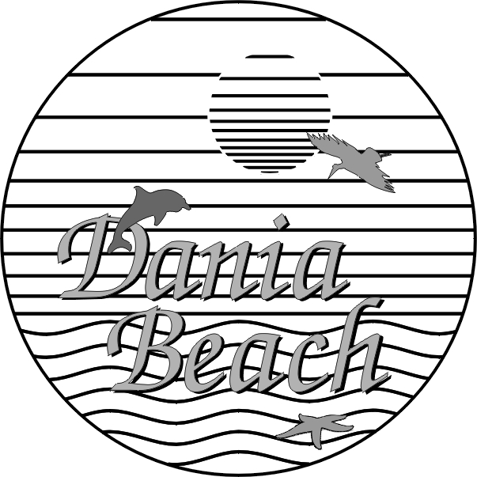
CITY OF DANIA BEACH

DEPARTMENT OF FINANCE
MEMORANDUM

TO: Robert Baldwin, City Manager Memo: DFA-16-013
Colin Donnelly, Assistant City Manager

FROM: Nicki Satterfield
Finance Director

DATE: June 10, 2016

SUBJECT: “Piggybacking” off State and Other Governmental Contracts and Co-op Contracts

Benefits of Piggy-back Contracts

There are several reasons for a governmental entity to utilize piggyback contracting, but fundamentally, the best procurement practices have the following elements

- Economic – best value through competition and best value for dollars spent.
- Equitable – fair contracting opportunities for vendors and that qualified vendors have access to the municipal market.
- Transparent - provides public confidence, more information disclosed, better ethical conduct and maximum disclosure of benefits to the public.

The theory behind piggyback contracts is the primary purpose of public procurement is to obtain quality goods and services to support effective and efficient government ensuring the use of public funds. As contracting workloads increase, purchasing requirements become more complex and as budgets and resources decline, procurement staff continues to seek new ways to deliver goods through an effective and efficient procurement process.

Piggyback contracts are one option staff can utilize which saves time and resources as well as leverage spending and creating economies of scale.
Saving Time – The RFP process involves extensive time by staff including but not limited to, Department Staff, Finance Staff, Legal Counsel review, and the City Clerk’s Office. Piggyback contracts:
- Avoid extensive time to develop the solicitation document
- Preparation to advertise the solicitation
- Accepting responses
- Performing a responsive review
- Evaluation/ Scoring etc.

Saving Resources
- Advertising costs
- Personnel Costs – time is money
- Allows employees to focus on other job assignments
Leverage Spending/ Economies of Scale
- Economies of scale are situations where the average cost of a product or service decreases when a business production or service increases. This results in businesses having the ability to share operating costs over a large number of units, or services which mean the City can obtain the best value for money.
- Examples of this include State of Florida Contracts, Co-op Contracts and Sheriff’s Contracts. All of these include many entities joining together to obtain best pricing and terms. By all entities joining together vendors are willing to provide goods and services a much lower pricing if entities were to bid separately.
Positive examples can include:
- The City purchases police and fire vehicles off statewide contract for significant cost savings.
- The City purchases computers off multi-state contract for significant cost savings
- The City purchases commodities off another local municipality’s contract for cost savings and efficient process to acquire.
- Because procurement rules have been satisfied since a contract has already been publically bid there is no risk of the City being forced to use an off-brand contractor.
- All statutory procurement requirements have been met and the time between project conception and start up can be greatly reduced. As a result, they are easier to administer.
- Consistency of cost is also a great example as price structures remain unchanged.
Virtually all governmental entities utilize piggyback options as a way of procuring goods and services in a competitive market. Since most entities require similar RFP requirements and restrictions, there is little concern or risk in utilizing existing contracts obtained by other governmental entities under a competitively bid process.
City of Dania Beach policy dictates all piggyback contracts must be competitively bid within the previous 18 months or be a contract extended under the same terms and conditions of a previously awarded contract within previous 18 months. This 18 month restriction ensures the City is receiving current recent pricing.
It is also important to note that piggyback contracts are typically used only for purchases and services contracts which are the same in nature with other entities (i.e. vehicles, equipment, or services). Constructions projects are very specific to Dania Beach and therefore would require the use of an RFP process under normal circumstances. Projects such as the Beach Redevelopment Plan, the OASIS Projects, and the Southeast Stormwater Projects are example of projects which could not utilize a piggyback option as their scope is so unique and specific to Dania Beach.

